**CIS-350  
Infrastructure Technologies**

**Lab 2 Report – Fall 2019**

**Student Name**: **________________________________________________________________**

**You must use this template to hand in Lab 2 Report.**

1. Insert *Lab2_Tree* file from p. 8 of the Lab 2 instructions into the space provided or use the *Alt-PrtScr* keys to capture the screen output (window) from command *TYPE Lab2_Tree* on p. 8 and paste that window here.

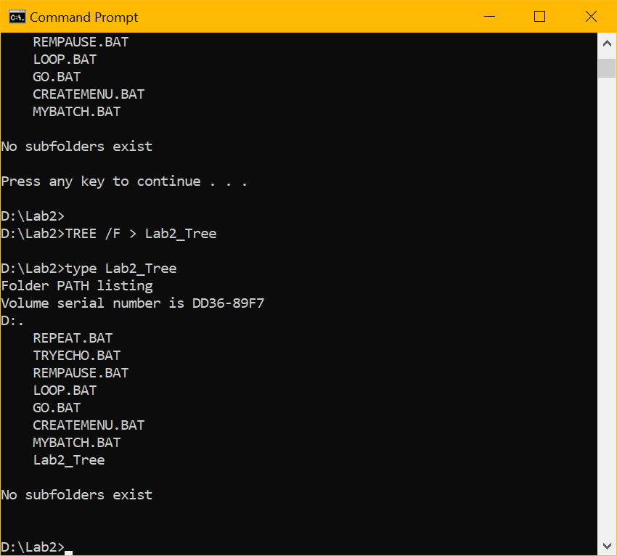

1. Assume that the system prompt displays "C:\>", i.e., your current directory and current drive are the root directory and C drive, respectively. Write a batch file below that will include commands to:
2. prevent all commands from displaying on the screen. Also, disable command ECHO OFF from displaying.
3. display the following message "My first script file"
4. display the directory hierarchy/structure of the C disk (Do not use DIR)
5. display the directory hierarchy/structure of the C disk with all files (Do not use DIR)
6. create subdirectory named *LETTERS* in the root directory
7. erase subdirectory *BOOKS* from the root directory
8. copy file *loop.bat* to directory *LETTERS*
9. pause the screen
10. use the piping operation to display the sorted directory and display it one screen at a time (prevent the screen from scrolling off). Need to use two pipes.
11. sort data in the descending order coming from file *Names1* and route the output to file *Names1_Sorted*

The batch file, commands (a) through (j):

**ECHO OFF**

**REM My first script file**

**TREE**

**TREE /F**

**MD LETTERS**

**RD BOOKS (OR ERASE BOOKS)**

**COPY loop.bat \LETTERS**

**PAUSE**

**DIR | SORT | MOREiop901**

**SORT /R < Names1 > Names1_Sorted**

Describe step by step what a file named MYSCRIPT does.

ECHO OFF

REM STARTING SCRIPT FILE

TREE /F

PAUSE

DIR

PAUSE

MD HANK TOM LISA

TREE /F

PAUSE

COPY *.BAT D:\LAB2\LISA

TREE /F

TREE

PAUSE

CD LISA

ERASE *.BAT

PAUSE

CD ..

TREE /F

PAUSE

RD HANK TOM LISA

TREE /F

PAUSE

REM CLOSING SCRIPT FILE

Assumptions: The prompt D:\LAB2> is displayed. D is the current drive and LAB2 is the current directory just below "\" (the root directory).

|  |  |
| --- | --- |
| **Command** | **Description (Fill in)** |
| **ECHO OFF** | Prevents all commands from being displayed on the screen. |
| **REM STARTING SCRIPT FILE** | Displays STARTING BATCH FILE. |
| **TREE /F** | Displays directory hierarchy starting with current directory, LAB2. |
| **PAUSE** | Pauses screen until user hits any key. Able to see previous command. |
| **DIR** | Displays directory contents. |
| **PAUSE** | Pauses screen until user hits any key. Able to see previous command. |
| **MD HANK TOM LISA** | Create 3 new directories: HANK, TOM, LISA in LAB2. |
| **TREE /F** | Displays directory hierarchy starting from current. Will show new 3. |
| **PAUSE** | Stops execution of batch file. Pauses screen until user hits any key. |
| **COPY *.BAT D:\LAB2\LISA** | Copies all files with .BAT extension from current directory to LISA directory. |
| **TREE /F** | Displays directory hierarchy. There are now files in LISA. |
| **TREE** | Displays hierarchy. |
| **PAUSE** | Stops execution of batch file. Pauses screen until user presses any key. |
| **CD LISA** | Changes the current directory to LISA. |
| **ERASE *.BAT** | Erase all files with .BAT extension from LISA. |
| **PAUSE** | Stops execution of batch file. Pauses screen until user presses any key. |
| **CD ..** | Returns to parent directory. LAB2. |
| **TREE /F** | Displays Directory Hierarchy. There will be nothing in LISA. |
| **PAUSE** | Stop execution of batch file. Pauses screen until user presses any key. |
| **RD HANK TOM LISA** | Removes the stated directories, JOE, MARY, STACY from directory. |
| **TREE /F** | Displays directory hierarchy from the current directory. Earlier directories are not shown or there. |
| **PAUSE** | Stops the execution of a batch file and pauses the screen until user presses any key. |
| **REM CLOSING SCRIPT FILE** | Displays CLOSING BATCH FILE. |